**DATA SHEET**

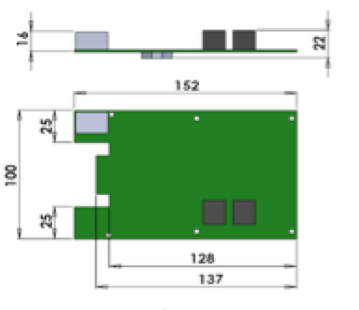

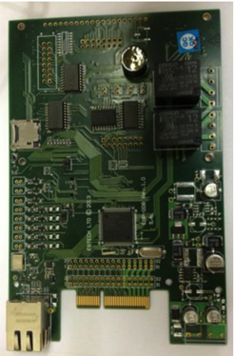

APPLICATION:  
The CUS-02 Control Unit is the product to which all products from Cabinet Security are connected to in order to have a complete package to secure a cabinet. It is powered by 12VDC and communicates through Ethernet.  
Upon request, the CUS-02 can also control other equipment in the cabinet, such as fan racks, lights, temperature and other customer specific options. The MBS-01 Motor Lock has a CUS-02 build in as a standard feature.  
  
FEATURES:  
The CUS-02 is an on-line system, but it can operate as a stand-alone unit. It can control two cabinet doors, each with two SHE-01 Swing Handle Locks and readers / keypads.  
Available with proximity cards reader or Keypad for One Time Password.   
TCP IP IPv4 and/or IPv6 Dual embedded stack and built in support for multiple network interfaces.   
  
SPECIFICATIONS:  
- 10 – 30 VDC Input voltage.

- 10 mA normal operations and   
 150 mA Max power consumption.  
- +5 - +80 C operating temperature range.  
- BSD style socket API.  
- Blocking / non-blocking socket operation and  
 event driven functions.  
- Well crafted TCP module with selective  
 acknowledgement (SACK) and congestion  
 control.  
- Raw socket interface.  
- Multicast support (IGMPv2 and MLDv1).  
- 65,000 tokens memory.  
- 65,000 events in audit trail.  
- 1A / 20 VDC open collector output -   
 flash upgradeable.